COACHING BACHELOR'S DEGREE PROGRAM
VOLLEYBALL SPECIALIZATION

Thematic topics for oral (30 points) and written (30 points) theory exams
- International and domestic history of volleyball.
- Rules of volleyball, with a specific focus on the latest rule changes.
- Significant international results, as well as great coaching and player personalities.
- The role of coordination abilities in volleyball.
- The role of conditional abilities in volleyball.
- Technical elements of attacking.
- Technical elements of defense (reception, floor defense, blocking).
- Tactical characteristics of service reception.
- Characteristics of attacking tactics.
- Characteristics of defensive tactics.

Recommended Literature:

- Official Volleyball rules
https://www.fivb.com/volleyball/the-game/official-volleyball-rules/

- AVCA (2015) Volleyball Coaching Bible, Vol II. , Human Kinetics Publishers

- Joel Dearing (2018) Volleyball Fundamentals – 2nd edition, Human Kinetics Publishers

Tasks for the Practical Exam (90 points)
Exercise 1: Proper execution of the overhand frontal serve to the opponent's court. From the service zone, 7 consecutive serves must be hit into the areas indicated on the diagram.

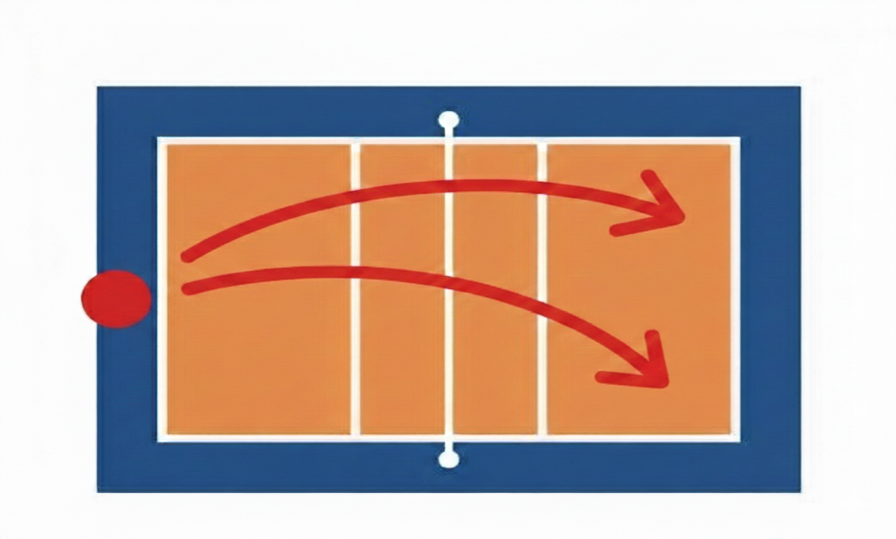

Exercise 2: Continuous ball control against a target marked on a wall using a specific sequence of technical elements (overhead pass - forearm pass or forearm pass - overhead pass). The distance from the wall must be at least 3 meters. Technical execution is judged according to the official volleyball rulebook.

Exercise 3: Receiving a ball initiated from the opponent's court, followed by a set and an attack (spike) over the net from position 4 (5 attempts).

