BACHELOR'S DEGREE PROGRAMME IN COACHING
FOOTBALL SPORT

Topics of the oral (30 points) and written (30 points) exams in sports theory

- The international and domestic history of football,
- The rules of the game of football, with special regard to the latest rule amendments,

- Major international achievements of the sport of football of domestic interest, great coaches and player personalities,
- The appearance of technical elements in different age groups.
- The appearance of tactics in different age groups.
- The appearance of coordination skills in football.
- The appearance of conditioning skills in football.
- Technical elements of the goalkeeper.
- Characteristics of game systems, line-up orders.
- Features of defensive and offensive tactics.

Recommended Reading
Göltl, B. (2002): Football Step by Step. MSTT, Budapest

The rules of the game of football 2025/2026.

Tóth J., Tóth Jr. (2022): Professional requirement for the preparation of junior footballers: University notes for the students of teacher and coaching majors. Private edition Budapest.

Tasks of the practical exam in the sport (90 points)

Exercise 1: Juggleing the ball with alternating legs

The exercise should be started by lifting the ball standing on the ground with your feet. The experiment ends when the ball hits the ground or at the request of the teacher who examines the applicant. (2 attempts)

Exercise 2: Shooting a standing ball into the goal

In front of the 7.32 x 2.44 m large goal, 5 balls placed on the line of 16 must be curved into the goal with 5 left and 5 with the right foot. (2 attempts)

Exercise 2 Representation

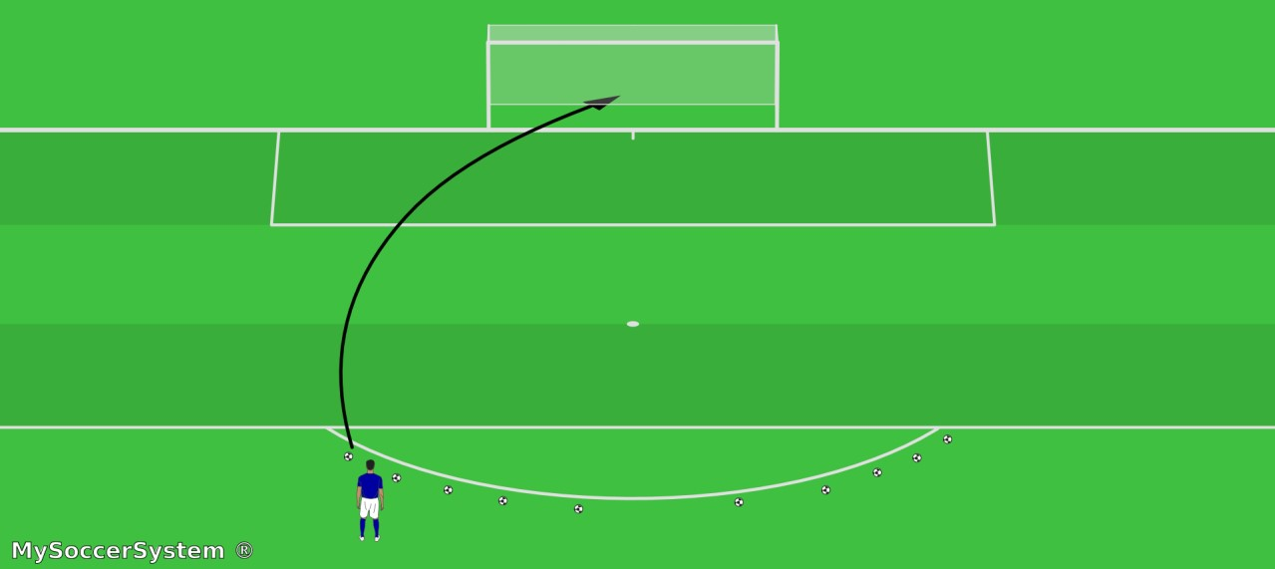

Exercise 3: Slalom ball control shot on goal.

Opposite the 7.32 x 2.44 m large goal, the exercise starts from the middle, 40 m from the goal. From the starting point, 6 buoys are placed 2 m apart. Alternating leg slalom dribbling by avoiding the cones. When leaving the 6th buoy, a flat pass to one of the boards 25 m from the gate. Two boards face the cones at a distance of 7.32 m from each other at 45 degrees in the width of the goal post line. The candidate can choose whether to pass to the right or left board. The ball returning from the backboard to the 16th round is shot into the goal after receiving it (does not roll it). (2 attempts)

3. Exercise Representation
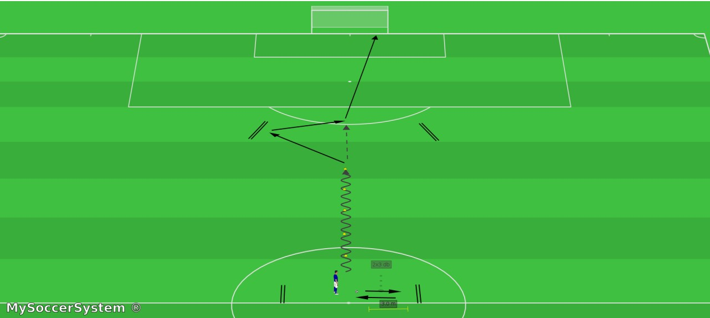

The exercises of the admission presentation can also be viewed as a video by scanning the QR code:
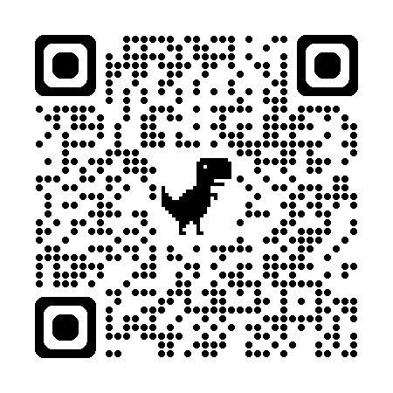
https://www.youtube.com/watch?v=p8q7RtjRHqk

